Strategic Management Project: Coca-Cola Company (Phase 3)
Portia Weiss
Saint Leo University
December 7, 2017
MBA 599 Strategic Management Module 8

Strategic Management Project: Coca-Cola Company (Phase 3)
Product- Positioning Map
Creating a product position map is also referred to as perceptual mapping. A product position map is a diagrammatic approach that is used by asset marketers to visually represent the perceptions of both current and potential consumers. The organization’s position in terms of brand, product or product line is mapped relative to the competition within the market that they exist in. Product positioning maps typically have two dimensions but in certain cases, they can be multi-dimensional when used to identify gaps in the market, potential merger targets or when seeking clarification of the perceptual problems that are associated with a company’s product (Quester et al., 2004). Creating an organization’s perceptual map allows the organization in question to understand their consumers better thus allowing them to be better placed to interpret consumer behavior as regards their products or services offered. In case the consumer perception of the company in question is negative, then the organization can conduct research on those grounds to determine what can be done to remedy the situation. A perceptual map similarly allows the organization to see how it is perceived especially by their competitors. In case an organization chooses to develop product position maps regularly, then they can be able to track consumer preferences and be better placed to deal with changes in the market. Product position mapping also facilitates the definition of market segments and clearly defines business clusters within the same thus providing the organization in question the opportunity to determine other businesses’ potential to partner or merge with suitable businesses. Perceptual mapping also allows an organization to track the progress of its new products in the market thus permitting the determination of its success or lack thereof considering its alignment with the business goals concerning positioning (Gelici‐Zeko et al., 2013).
Market segmentation is important because it allows the brand to identify the products that can suit the needs of different consumers. However, Coca-Cola does not necessarily target a specified market segment and it adjusts its market strategy through the development of new products. In terms of age, Coca-Cola does not target any specific age group, but it is mainly consumed by those between the ages of 12 and 30 years. Regardless, Coca-Cola has also managed to reach those that are not in the age bracket specified above through their partnerships with fast food franchises, restaurants or the value that the brand gives to its consumers. Therefore, Coca-Cola mainly targets the youth and from statistics collected members of both genders consumer Coca-Cola products at an almost equal rate. Furthermore, every customer is considered a target as well as a potential consumer by Coca-Cola. Those between the ages of 18 and 25 depict the greatest target population potential and as such are prioritized by the organization. The organization named above is not occupation oriented and instead tends to be family oriented (Sinha et al., 2009).
Initially, Coca-Cola’s brand position was under a medicine patent as a cure for both fatigues and headaches. However, the latter was changed with the implementation of tax imposition of 1898. As of 2014, the organization’s unique selling position (USP) was “Live on the Coke side of life.” Its products thrive under the perception of being refreshing and sources of quenching thirst. The latter also has a cultural value among friends and family and the joyful moments shared with others. Consumers have also associated the same with high quality and high consistency levels. Therefore, the factors that must be considered when referring to Coca Cola’s brand position include distribution, packaging, promotion, competition, and price. In terms of pricing, Coca-Cola’s prices remained constant for about 70 years regardless of the prevailing and changing market conditions. Its packaging has however been altered over the years to fit market trends and maintain a superior look among other brands in the market. In terms of promotion, Coca-Cola believes in “letting the word spread,” that is, creating awareness as well as reminders and keeping up with its competitors. The Coca-Cola slogan changes periodically, however, the bottom line is maintained depicting organizational brands as high-quality products that bring people together (Fournier & Avery, 2011).
As previously stated, Pepsi is Coca Cola’s biggest competitor. Pepsi’s current brand positioning is based on their slogan, “Live for Now.” The latter encourages their consumers to live life to the fullest and come together through music, entertainment and pop culture (Ferreira et al., 2008). In contrast, Coca-Cola appeals to an important part of people’s daily lives and creates an intimate relationship with consumers by encouraging them to summon past experiences they have had with the brand. The brand stresses that its consumers should live on positively by creating a positive reality and also establishing a similar reality for others. Concerning brand differentiation, Coca-Cola stands out when compared to other brands because it has made itself out to be a symbol of both fun and joy, it has created a product line with culturally tailored products and has included an organic beverage line. Thus, the latter allows it to have a competitive advantage over its competitors in terms of being a market leader, formulation of strategic business partnerships, establishment of consumer relations that are collaborative, and multiple segmentation of the brand. Also, Coca-Cola has well-established client value management systems, an impressive and well-organized marketing strategy, expert managers, development strategies that are sustainable and a flexible sales and distribution model, all of which are factors that give it an advantage over its competitors (Cayla & Arnould, 2008).
Product Positioning Map
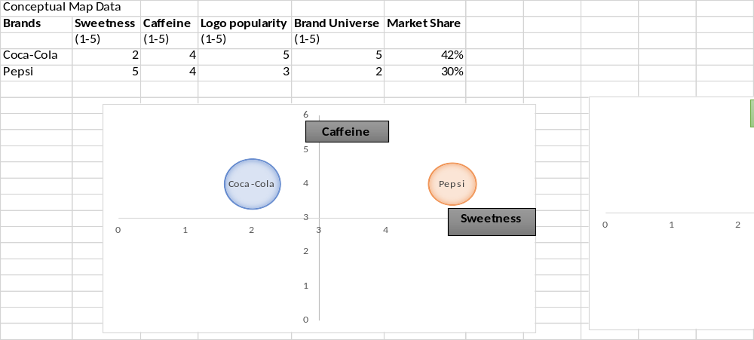
From the maps above, it is evident that consumers prefer Pepsi’s taste to Coca-Cola’s. Both drinks have similar amounts of caffeine, but Coca-Cola’s logo popularity is significantly higher when compared to Pepsi’s. Coca-Cola has also established an extensive brand universe compared to Pepsi, all of which are contributing factors to the market share each of the two brands possesses with Coca-Cola being the biggest shareholder garnering 42% with and possessing 30% of the same.
Strategies and Objectives for most Favorable Market Position
If Coca-Cola is to continue growing and manage to at maintain and further increase its market position, it must consider adopting new strategies over time to allow the organization to be better placed to succeed regardless of the prevailing market conditions. However, strategic changes should focus on increasing the strengths of the organization and decreasing its weaknesses as well as maximally exploiting the opportunities available to the same and mitigating the effects of the threats thereof. First, considering the stiff competition that Coca-Cola faces from Pepsi, the organization must strategize to find means through which it can eliminate the competition once and for all. To begin with, Coca-Cola can find means to further diversify their product portfolio to grant them an opportunity to reach a wider range of consumers. Heightened consumer numbers translate into higher revenue, increased brand awareness and often an increased market share which will mean that the stiff competition from Pepsi may be reduced significantly.
Similarly, with the increasing rate of consumer preference changes, Coca-Cola should consider exploring new product lines that consumers are likely to be more interested in. In an era characterized by increased health awareness resulting from the escalation of the prevalence of lifestyle diseases, the organization should consider investing more in the production of healthier drink choices. The more the healthier the drinks they produce, the higher the number of consumers they are likely to attract thus allowing them to secure a more favorable market position. Resource management is also a key factor that must be considered if the organization is to maintain a favorable position in the market. The latter means that the management team should ensure that resources are allocated in a manner that allows their effective and efficient utilization, avoiding over-allocation of the same across projects. With that respect, the resource allocators must also understand that there is a need to focus resources on one project at a time instead of constantly abandoning ongoing projects for new ones if the organization is to succeed in the project implementation since because fragmentation negatively impacts progress and results (Sirmon et al., 2008).
With the constant changes in the business environment, for Coca-Cola to maintain a competitive advantage over the rest of the brands in the industry, it must consider reinventing its supply chain to fit the current trends in the market. The more the supply of Coca-Cola products meets the needs of consumers, the higher the chances of organizational success as the latter is likely to translate into increased brand loyalty. Moreover, Coca-Cola should consider allocating more advertising resources to the less popular brands to increase their popularity among consumers. The latter is likely to lead to an increased consumer base as people adapt to the consumption of the less popular products. On the other hand, Coca-Cola must look to find means to decrease or eliminate indirect competition. The latter may be done by making the organization a beverage company rather than a soft drink company. In so doing, the indirect competitors will now become direct competitors thus allowing Coca-Cola to have higher chances of success in maintaining its market position or further strengthening the same.

Selected Strategy: Product Portfolio Diversification
Product portfolio diversification is a term that is used to refer to the processes that are involved in expanding business opportunities by adding the market potential of a brand that already exists. An organization/ business may achieve diversification through entry into new markets or changing their pricing strategies. The new products are likely to be changed, improved or the marketing activities associated with the product/brand in question altered. In the case that an organization is looking to diversify their product portfolio, they must set the objectives of the latterly named move and their approach towards the same may be defined as either defensive or offensive. A defensive approach can be adapted when a business is looking to beat stiff competition, increase lowered demand for their products or add more products to a brand that was built based on a single product. An offensive portfolio diversification approach is however adapted in case there is a strong market opportunity and the existing company products cannot be used to exploit the same (Jacobs & Swink, 2011).
As Coca-Cola considers taking on a product portfolio diversification approach to attaining a favorable market position, the organization should use both offensive and defensive tactics with that regard to fully exploit organizational potential and maintain their position as market leaders. For Coca-Cola to gain a competitive advantage and maintain a market position that is favorable it must beat the stiff competition that Pepsi and other beverage organizations offer. Similarly, the defensive approach to product diversification at Coca-Cola will allow the organization to heighten the demand of their product whose demand have seemingly decreased, like is the case with its carbonated sugary drinks in developed countries. The later will also allow Coca-Cola to increase its products to include more than the initially branded ones thus raising the organization’s chances of increasing its customer base considering the wider range of products to choose from. On the other hand, an offensive approach to diversification would allow Coca-Cola to exploit the new market for healthier drinks since the consumer preferences have seemingly been moving in that direction in the recent past.
The stiff competition between Coca-Cola and Pepsi has existed since the late nineties and has been branded as the cola wars. The latter is characterized by marketing campaigns as well as television advertisements created by both organizations targeting mutual areas of interest. During the competition periods, the two organizations contrast based on the strategies that they employ to avoid competition, their focus on different consumers, and sponsorship of differing sports and differentiation of logos among others (Crosetto & Gaudeul, 2017). Hence, for Coca-Cola to gain a more suitable market position with that regard, they should further diversify their product portfolio to include products that are not offered by Pepsi such that they can take possession of a market niche within which the competition is not as stiff or where the same is minimal. Moreover, when Coca-Cola Company was established, the drink that it promoted mainly was Coke, also referred to as Coca-Cola. Over the years, as the company grew and the trends in the market changed, there was a need to diversify the products offered and the latter saw to the introduction of others like Fanta and Sprite. The same was the cause for the introduction of the organization’s other products including bottled water, minute maid and diet coke among others. However, the changes that already exist with regard to product portfolio diversification cannot be considered satisfying since the market trends are still changing which means that the consumer preferences, resultantly, keep diversifying. In the current market, consumers beverage and food trends are dominantly inclined to healthier choices such that even established organizations like Coca-Cola are either looking to reformulate their old brands or introduce new products altogether to satisfy consumer needs and maintain a market position that is favorable. According to surveys, consumer preferences for drinks that are healthier indicate that about 90% of consumers are more than willing to pay more to enjoy the benefits of high-quality goods (Hoke et al., 2017). The latter is likely to propel the offensive approach to product diversification that Coca-Cola should consider taking. The current beverage market provides an incredible opportunity for the organization to grow in terms of the products offered to consumers as well as revenue accrued. Since Coca-Cola has previously focused on the production of sugary carbonated drinks, part of its diversification strategy should include introducing drinks that are healthier and advertising them frantically to increase consumer awareness of the new products. This will allow the organization to tap into a new market niche which will potentially translate into increased revenue and a better market position.
Implementation and Assessment Plan
The first step towards implementing the diversification plan will be conducting a market research. Market research is also referred to as industrial research which accounts for application of organized efforts to collect information concerning consumers in Coca Cola’s target market. The latter allows the evaluation of both social and opinion aspects provided by the consumer making it essential to strategic business approach. Market research would grant Coca-Cola the opportunity to maintain a competitive advantage over their competitors allowing them to remain as market leaders in the niche within which they operate. It offers the researcher an opportunity for identification and analysis of needs in the market regardless of whether the approach towards the same is quantitative or qualitative (McQuarrie, 2015). Coca Cola’s market research would, therefore, cover aspects of market trends, information, segmentation as well as SWOT analysis, among others, most of which have been highlighted in the all phases of this research.
The next step to be taken towards implementation is the analysis of product adaption. The term product adaptation refers to the modification of products that that already exist such that they are more suited to cater to the needs of different market niches and consumers. Considering that Coca-Cola operates across international borders, analysis of product adaption is necessary since it will ensure that the product (s) the organization offers its consumers meet both the cultural and regulatory requirements thereof. Product adaptation would also be essential as Coca-Cola looks to introduce new products which are not necessarily new items. Analysis of product adaptation will, therefore, entail the evaluation of consumers, research, and competition. Finally, the organization should set priorities to determine the exact nature through which product adaptation should be implemented (Sridhar & Mishra, 2011). Product adaptation analysis will allow Coca-Cola to determine which diversification approach it should implement and in which regions depending on the market niche needs in thereof.
The last step of product diversification is a legal review. Legal review entails sending a document or documents to a legal professional for them to review and send feedback (Clayton, 2015). Legal reviews are important to the diversification process as they ensure that the efforts the organization makes towards the same are in line with the set laws to avoid resource wastage associated with dealing with legal issues. The latter also allows the organization to avoid the bad publicity that may result from legal implications which may cause reduced consumer confidence in the products offered by the organization.
The specific results that must be achieved through the latterly described implementation process include increased market share. Through product diversification, Coca-Cola should be able to control about 50% of the market or more before the end of the next financial year. Similarly, the organization should be able to increase its financial stability because of product diversification. The brand value should increase to about 73.8 billion from 73.1 billion US dollars and the operating revenue increase from 41.86 to 42.3 billion US dollars within the next year. In terms of products, the strategy explained above should allow Coca-Cola to introduce at least five new products in the next year, mainly focusing on introduction of healthier choices and tapping into new market niches. Furthermore, the organization should be well placed to offer better services to its consumers who will be able to access healthier drink choices from a trusted brand (Thomas, 2009).
The effectiveness of the implementation process will be evaluated after every three months with regards to the set market, financial, product and service goals. Each assessment will include documentation of evidence in photos, figures and graphs depending on the most appropriate way of presentation of data collected and the goals being assessed. At the end of the financial year, all the evidence that was documented within the same will be compiled to establish the trends depicted concerning goal attainment. Similarly, the gap between the reported organizational performance and the set goals, if any, will be analyzed to justify the same and determine what Coca-Cola can do to eliminate it and increase the chances of attaining the goals set for the next financial year. The evidence will be collected mainly through analysis of accounting records and monitoring social media as well as customer care channels to determine consumer response to the brand and its specific products. A special strategy assessment team will be put together, comprising of members from different levels within the organization, to conduct the periodic assessments that will determine the effectiveness of implementation of the product diversification strategy.
Financial Projection
Financial projections are comprised of estimated values of future organizational performance. They are important to the success of a business because they establish clear guidelines through which organizational success may be measured. In the case that financial projections are made regularly, an organization is better placed to deal with change that occurs in both its external and internal environment. Financial projections also allow the evaluation of an organization’s strengths and weaknesses as well as the determination of available opportunities hence facilitating preparedness to beneficially exploit the market. The same applies to the recognition of problems and threats that the organization may face leading to timely reactions that mitigate the negative effects that may result from the same. Generally, financial projections allow the organization to react to the changing marketing conditions in a manner that allows it to maximally benefit from the same. The main objectives of creating financial projections include; it facilitates the translation of organizational goals into specific goals, it acts as a feedback and control tool in the organization and allows problem anticipation to better prepare for the same (Chilombo et al., 2008).
The type of financial projection created is dependent on an organization’s objectives as well as its situation. The first type of projection that can be made is an annual forecast that may be updated monthly making it the main monitoring and evaluation tool within the organization. The latterly named type of projection also forms the basis for the creation of other types of forecasts. An organization may likewise choose to work with a long-term projection which forecasts its financial position over the next 3-5 years. Unlike the short-term forecast that is characterized by tactical and expectation plans, the long-term projection accounts for the strategic organizational goals in place. Similarly, financial projections may be characterized by budgets that translate the goals of an organization into temporary targets and detailed actions that may include details of organizational plans regarding staffing and expenditure on line items. Lastly, financial projections are also characterized by cash flows which further breakdown annul forecasts into greater detail targeting the monitoring of the flow of cash within an organization rather than the profits accrued by the same. A well-established financial plan should have cash needs that are properly defined through the creation of an accompanying cash flow statement. Thus, the financial projection made for Coca-Cola is a long-term forecast that accounts for three years after the end of the 2017 financial year (Chilombo et al., 2008).
The key elements of a financial projection include the statement of income, projection of cash flow, and the balance sheet. The statement of income is comprised of all aspects of a business including its expenses, profits, and revenues within the specified period. The main sections of the same include expenses, revenue, total income, income accrued from taxes and net income. Next is the projection of cash flow. It records the flow of cash in a business and can be used to convince potential investors or creditors that the latter has a good credit risk and can manage to pay back a loan, in case it is granted. The main parts of the cash flow projection include cash revenues, disbursements and the reconciliation of the two aspects previously named. The balance sheet provides an overview of how much a business is worth within a specific period. It summarizes the financial data associated with a business into three categories, that is, assets, liabilities, and equity (Elliott & Elliott, 2007).
The Coca-Cola financial projection below indicates that the net operating revenue in the financial year that ended on the 31st of March 2017 was $41863 million and the figure is expected to rise steadily and at the end of the three-year period covered by the projection be $73219 million. The gross profit that was recorded in the 2017 financial year was $25398 million and the figure is expected to rise to $53205 million after three years. The organization’s net income, income before taxes and consolidated net income are expected to rise significantly with margins of over $12 million over the projected period. In the cash flows statement, the net cash that is accrued from operating activities is expected to increase from $5668 to $ 46634 million. Similarly, the net cash that is used in investing is also expected to increase from $1794 million to $21153 million at the end of the three-year projection period. The balance at the beginning of the period should increase from $4093 million to $5182 million while the balance at the end of the period is forecasted to decrease progressively from $7797 million to $5442 million. In the balance sheet, the organizational total assets are expected to double within the three years while total equity is expected to triple. See the spreadsheet below for details.
Coca-Cola 3-Year Financial Projection

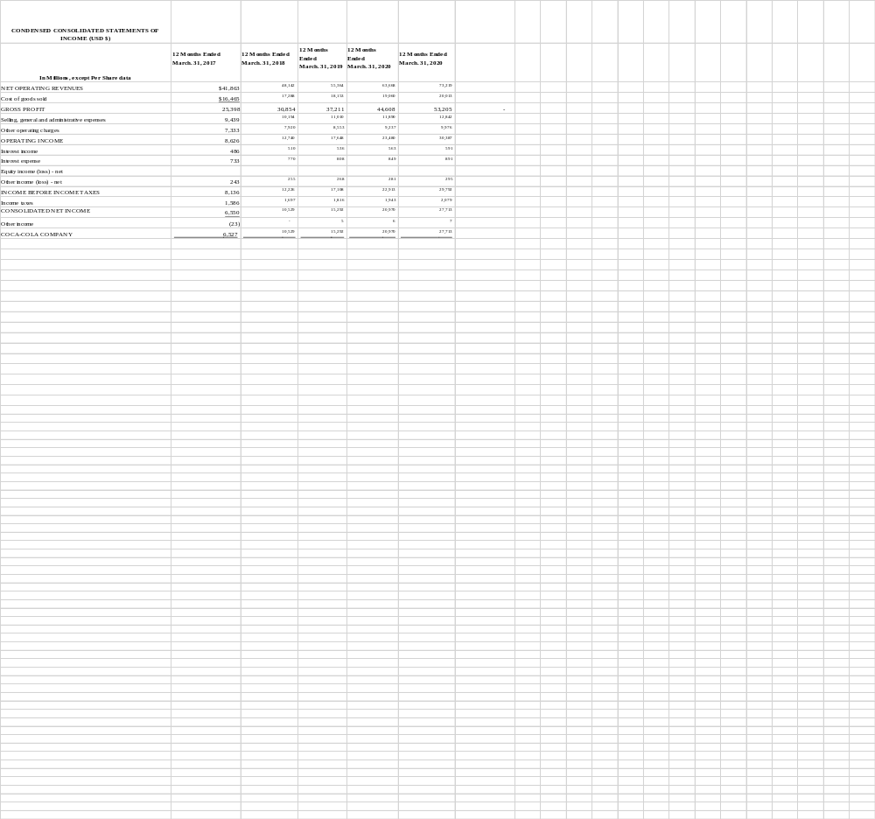

References
Cayla, J., & Arnould, E. J. (2008). A cultural approach to branding in the global marketplace Journal of International Marketing, 16(4), 86-112
Chilombo, N., Doetinchem, O., & Kansembe, H. (2008). Financial projections for social health insurance in Zambia Genève, Organisation mondiale de la santé (non publié)
Clayton, C. W. (2015). The Politics of Justice: Attorney General and the Making of Government Legal Policy. Routledge
Crosetto, P., & Gaudeul, A. (2017). Choosing not to compete: Can firms maintain high prices by confusing consumers? Journal of Economics & Management Strategy, 26(4), 897-922.
Elliott, B., & Elliott, J. (2007). Financial accounting and reporting. Pearson Education
Ferreira, M., Hall, T. K., & Bennett, G. (2008). Exploring brand positioning in a sponsorship context: A correspondence analysis of the Dew Action Sports Tour. Journal of sports management, 734-761
Fournier, S., & Avery, J. (2011). The uninvited brand. Business Horizons, 193-207.
Gelici‐Zeko, M. M., Lutters, D., Klooster, R. T., & Weijzen, P. L. G. (2013). Studying the influence of packaging design on consumer perceptions (of dairy products) using categorizing and perceptual mapping. Packaging Technology and Science, 215-228.
Hoke, O., Campbell, B., Brand, M., & Hau, T. (2017). Impact of Information on Northeastern US Consumer Willingness to Pay for Aronia Berries. HortScience, 395-400.
Jacobs, M. A., & Swink, M. (2011). Product portfolio architectural complexity and operational performance: Incorporating the roles of learning and fixed assets. Journal of Operations Management, 677-691.
McQuarrie, E. F. (2015). The market research toolbox: a concise guide for beginners. Sage Publications.
Quester, P. G., McGuiggan, R. L., Perreault, W. D., & McCarthy, E. J. (2004). Marketing: creating and delivering value.
Sinha, J. I., & Rosenthal, E. C. (2009). The costs and perils of over-targeting in today's markets, The Marketing Review, 9(3), 243-250.
Sirmon, D. G., Gove, S., & Hitt, M. A. (2008). Resource management in dyadic competitive rivalry: The effects of resource bundling and deployment. Academy of Management Journal, 919-935.
Sridhar, G., & Mishra, D. (2011). Executive’s social representation of rurality and product adaptation: a case of rural markets in India. Asia Pacific Journal of Marketing and Logistics, 285-303.
Thomas, M. (2009) Belching out the devil: Global Adventures with Coca-Cola Nation Book
Wedel, M., & Kamakura, W. A. (2012). Market Segmentation: Conceptual and methodological foundations (Vol. 8). Springer Science & Business Media

